E-Check Authorization

For your convenience, RISCOM now offers an e-check service for your payments. You may schedule your payment to be automatically deducted from your checking or savings account.

E-Check payments will make your life easier and more convenient by saving you time, postage and wiring charges from your bank.

In order to enroll in this service, please complete the information below:

I authorize Regional Insurance Services Company, LLC (RISCOM) to initiate an electronic debit entry.

Account Type: ☐ Checking ☐ Savings
Name on Account: Click here to enter text.
Bank Name: Click here to enter text.
Bank City/State: Click here to enter text.
Account Number: Click here to enter text.
Routing Number: Click here to enter text.

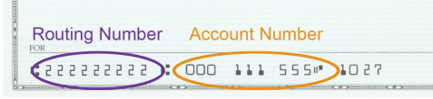

Transfer Date: Click here to enter text.
Amount of Transfer: $ Click here to enter text.

Signature of Representative _______________________ Date ____________________

*Please submit this form with a voided check. Keep a copy of this authorization for your records.

